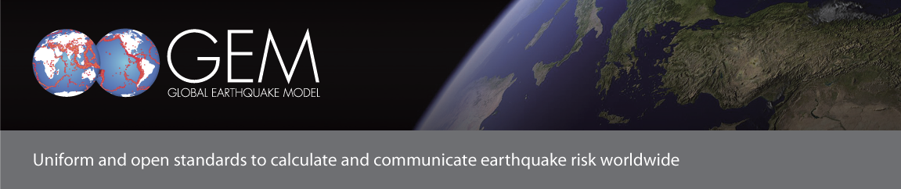
DRAFT 7 Agenda for the 6-8 June 2012 GEM Semi-Annual Meeting

Hosted by Taiwan Earthquake Model (TEM) at Academia Sinica
No. 128 Sec. 2, Academia Road, Taipei, Taiwan

6 June: Field trip to the 921 (Chi-Chi) Earthquake Museum; Evening reception in Taipei
7 June: 2nd Conference room, H.S.S. Building of Academia Sinica
8:30 – 8:45 Introduction
Welcome: Kuo Fong Ma (TEM) and Ross Stein (GEM)
8:45 – 9:20 GEM Outstanding Contribution
Bestowal of the GEM Outstanding Contributions Award to Kishor Jaiswal
Presentation by Kishor Jaiswal on his work and his aspirations for GEM
9:20 – 10:30 OpenQuake
Highlights of the OpenQuake engine development and the OpenQuake platform
10:30 – 11:00 Coffee Break
11:00 – 13:00 Hazard
Global activities
- Global Seismic Instrumental Catalogue (Dmitry Storchak)
- Global Active Faults and Seismic Sources Database (Nicola Litchfield)
- Global Geodetic Strain Model (Zheng-Kang Shen)
- Other Global Components and integration within hazard models (Marco Pagani)

13:00 – 14:00 Lunch

14:00 – 15:30 Hazard

Regional focused talks
- Taiwan Earthquake Model (Kuo Fong), with highlights of the TEM-NIED workshop (Ken Hao/Hiroyuki Fujiwara)
- AUSAID/Geoscience Australia’s South East Asia GEM-coordinated programs (Trevor Allen/Nick Horspool/John Schneider)
- NTU/EOS GEM research: Indonesia & Myanmar (Kerry Sieh/Paul Tapponnier/Domenico Giardini)
15:30 – 16:00 Coffee Break
16:00 – 19:00 Hazard
Examples of TEM efforts in Southeast Asia countries (15 min each with Q&A)
- Seismic network development for Southeast Asia (Bor-Shouh Huang)
- Site Effect Measurement in Hanoi, Vietnam (Kuo-Liang Wen)
- GPS observations and potential earthquake rupture sources in northern
Luzon, Philippines (Ya-Ju Hsu)
15 min talks highlighting seismic hazard studies in Asian countries
- Indonesia (Danny Natawidjaya)
- Vietnam (Phuong Hong Nguyen)
- Korea (Myung-Soon Jun)
- Philippines (Renato Solidum, Leyo Bautista or Bart Bautista)
- India (Ravi Sinha or Anup Karanth)

Group Dinner (at the hotel restaurant, or perhaps at the Grand Hotel Taipei)
8 June: 2nd Conference room, H.S.S. Building of Academia Sinica
8:30 – 10:30 Physical Risk
- Overview of Physical Risk Global Components (Helen Crowley)
- Chinese data for the Global Exposure Database (Beijing Normal University representative)
- Inventory Data Capture Tools – lessons learnt from Indonesia exposure model development (Ron Eguchi/John Bevington)
- Christchurch post-earthquake field data for the Global Earthquake Consequences Database (To be confirmed)
- Testing the Vulnerability Guidelines using Australian data (Mark Edwards/Syed Tariq Maqsood)
10:30 – 11:00 Coffee Break

11:00 – 13:00 Other GEM Highlights
- Social Vulnerability and Resilience Project (Christopher Burton and Bijan Khazai)
- GHI study of Beneficiaries’ Needs (Anup Karanth or Hari Kumar)
- SHARE: a completed GEM Regional Programme (Domenico Giardini)

13:00-13:30 Closing Comments on the State of GEM by Secretary General (Rui Pinho)

13:30 – 14:30 Lunch

